OPG / Ceph Request Form
Patient details:
Title: First name: Last name:
Address:
Postcode: D.O.B
Tel (h): Tel (w): Mobile:
Email: Preferred contact method:
Referring Dentist details: N.B. Please complete al fields
Dentist name: Practice:
Practice address:
Postcode: Practice tel:
Email:
Brief patient history:
Reason for OPG / Ceph:
Specific field of view required:
☐Full Panoramic £70.00
☐Cephalometric £60.00
☐Sectional: Please mark area(s) on diagram below

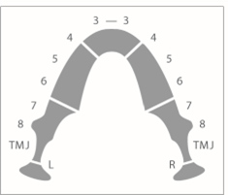
Dentist signature:

GDC number:
OPG / Ceph charges are to be paid by the patient in advance of their appointment.

